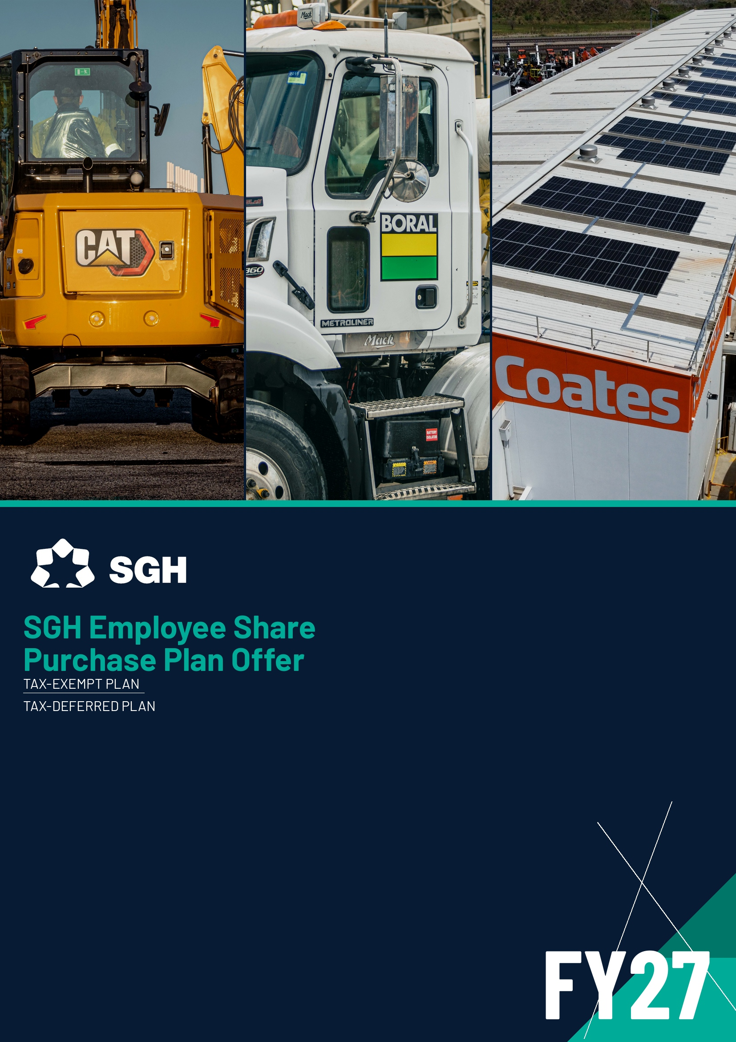

FY27 SGH EMPLOYEE SHARE PURCHASE PLAN OFFER
Introduction
The SGH Limited (SGH) Employee Share Purchase Plan (ESPP) is designed to give eligible permanent employees across SGH the opportunity to build ownership in SGH by purchasing shares on a pre-tax, salary-sacrifice basis.
Participants salary sacrifice the value of the shares they are purchasing over an eight-month period, with funds used to purchase SGH shares three times a year in arrears. To ensure there are no potential conflicts with the SGH Share Trading Policy, the shares are purchased:
- Following the SGH Annual General Meeting;
- Following the release of the half-year results; and
- During May, prior to the end of the financial year on 30 June.
Once shares are purchased, they are held in an employee's share plan account with Boardroom Pty Limited (Boardroom), the SGH Share Plan Manager. As with other SGH shares, any dividends SGH pays to shareholders are also paid on shares purchased through the ESPP.

TWO WAYS TO TAKE PART
The Tax-Exempt Plan - where, subject to meeting certain criteria, the acquisition of the shares is tax-free.
The Tax-Deferred Plan - where the tax on the acquisition of the shares is generally deferred for two years from the date they are purchased.

To comply with taxation requirements, shares purchased through the ESPP must be held for a specific period and are subject to a holding lock which prevents them from being traded. This offer document outlines how the ESPP works, how to participate, and general taxation information. The taxation information does not take into account your personal circumstances or constitute tax advice. Please read this guide carefully and consider obtaining independent advice before deciding whether to participate.

Key dates
The key dates for the FY27 Employee Share Purchase Plan are set out below. Dates marked “~” are indicative and may be adjusted to comply with the law or the SGH Share Trading Policy.
Milestone | Date
Offer period commences | ~1 September 2026
Offer period closes | ~15 September 2026 (5:00pm AEST)
Contribution period | October 2026 – May 2027
Expected share acquisition | November 2026 · February 2027 · May 2027
Restriction period — Tax-Exempt | 3 years from the acquisition date*
Restriction period — Tax-Deferred | 2 years from the acquisition date*
*The Restriction Period will be lifted earlier upon your ceasing employment with SGH.
How the plan works
- 1 - You choose: pick the Tax-Exempt Plan, Tax-Deferred Plan, or both, and your contribution amount.
- 2 - You contribute: equal instalments are salary-sacrificed from your pre-tax pay, Oct 2026 – May 2027.
- 3 - SGH buys: shares are acquired on-market in three instalments — Nov, Feb and May.
- 4 - You own: shares are held by Boardroom, earn dividends, and unlock after the holding period.

PART A · OVERVIEW OF THE PLANS
Terms of the FY27 Plan
SGH operates both a Tax-Exempt Plan and a Tax-Deferred Plan (together, the Plans), allowing employees to acquire SGH ordinary shares in two ways. You may participate in one or both, subject to meeting the relevant eligibility and minimum-purchase requirements.
Tax-Exempt Plan — $1,000 fixed
- Acquire $1,000 of SGH shares from pre-tax salary and wages.
- Acquired tax-free for participants earning adjusted taxable income not exceeding $180,000 p.a.
- Above $180,000 you may still participate, but shares are taxed at your marginal rate.
- Restriction Period of 3 years from the allocation date (or earlier on ceasing employment).
Tax-Deferred Plan — $2,500 to $5,000
- Acquire up to $5,000 of SGH shares from pre-tax salary, in $500 increments.
- Income tax on acquisition is generally deferred for 2 years from allocation.
- Minimum purchase of $2,500 if taking the Tax-Deferred Plan only.
- Restriction Period of 2 years from the allocation date (or earlier on ceasing employment).
Participating in both Plans
Where you choose both Plans, your minimum purchase must be at least $3,500 (Tax-Exempt $1,000 + Tax-Deferred $2,500). You can purchase up to $6,000 in $500 increments (Tax-Exempt $1,000 + Tax-Deferred up to $5,000). You cannot acquire more than $5,000 worth of shares under the Tax-Deferred Plan.

CHOOSING WHAT'S RIGHT FOR YOU
Your participation in one or both Plans is a matter of personal preference and circumstances, and the tax treatment of the two Plans is very different. Please read this booklet in full and consult your accountant, solicitor or licensed financial adviser before deciding. SGH reserves the right to withdraw the offer at any time.

Contribution period & pay cycles
To simplify the salary-sacrifice calculations, the Contribution Period runs from October 2026 to May 2027, which contains 8 monthly, 16 fortnightly, or 30 weekly pay cycles. The table below shows the contribution per pay period for various levels of participation.
You invest | $1,000 | $2,500 | $3,000 | $5,000
Weekly | $33 | $83 | $100 | $167
Fortnightly | $63 | $156 | $188 | $313
Monthly | $125 | $313 | $375 | $625

REMEMBER
Because contributions come from your pre-tax salary, the effect on your take-home pay is less than the amounts shown. The actual number of shares acquired depends on the market value of SGH shares (ASX: SGH) when purchased — in November 2026, February 2027 and May 2027.
Part A · Questions
1. What is the FY27 Invitation?
SGH is offering you the choice of acquiring ordinary shares in SGH (ASX: SGH) through the Tax-Exempt Plan and/or the Tax-Deferred Plan. You may elect one or both, or choose not to participate (in which case you wait until the next invitation, expected in 2027). The Invitation is made under the Plan Rules; where there is any inconsistency, this Invitation document prevails.
2. What is the difference between the two Plans?
The main differences are the number of shares you can acquire and how your shares are treated for tax purposes — see the comparison above and Part C.
3. Can I participate in both Plans?
Yes - as long as you meet the minimum purchase requirements for the Tax-Deferred Plan. Note the adjusted taxable income cap of $180,000 that applies to the Tax-Exempt Plan (see Part C).
4. How much do I pay for the shares?
Under both Plans you elect to “sacrifice” an amount of pre-tax salary, deducted in equal instalments each pay during the Contribution Period. For example, $1,000 via the Tax-Exempt Plan is $125 per monthly pay or $62.50 per fortnight. As it is pre-tax, the effect on your after-tax pay is less. SGH allocates a whole number of shares of equivalent value (rounded down), acquired on-market in three instalments (on or about 27 Nov 2026, 26 Feb 2027 and 26 May 2027).
5. How many shares will I acquire?
Approximately equal to the amount you contribute, based on the average acquisition price on each allocation date. Fractions are rounded down; any remaining amount carries to the next allocation or is returned as gross pay (less tax) after the final allocation.
6. When are the shares acquired?
On-market in three instalments, on or about 27 November 2026, 26 February 2027 and 26 May 2027. SGH may change the dates, and may issue new shares rather than buy on-market; you will be notified.
7. Restrictions (holding lock)
You must hold shares for a minimum Restriction Period (3 years Tax-Exempt; 2 years Tax-Deferred, or earlier on ceasing employment), during which a holding lock prevents you selling, transferring or otherwise dealing with them. You still receive dividends and can vote, and must comply with the SGH Share Trading Policy at all times.
8. Does the salary sacrifice impact superannuation?
No. Your employer's Superannuation Guarantee contributions stay the same and are not reduced by amounts used to purchase shares.
9. Who can participate?
All Australian full-time, permanent part-time and fixed-term employees of SGH and its subsidiaries who are residents of Australia for tax purposes and have at least six months' service. For FY27 you'll need to have commenced on or before 1 July 2026. Non-executive Directors, casual employees and fixed-term contractors are not eligible.
10. How do I participate?
Boardroom emails eligible employees an invitation; follow the steps in it and complete by 15 September 2026 (5:00pm AEST), choosing the Tax-Exempt Plan and/or the Tax-Deferred Plan. If you don't wish to participate, you don't need to do anything.
11. Further information
Contact Boardroom on 1300 737 760 or email SGH@boardroomlimited.com.au for a response within 24 hours.

PART B · FREQUENTLY ASKED QUESTIONS
Your questions, answered
These FAQs provide general information only. Any advice is general advice only — please seek advice from your accountant, solicitor or licensed adviser about your particular circumstances.
Q1. What are shares?
SGH Limited (ACN 142 003 469) is a public company listed on the ASX under the ticker “SGH”. Acquiring shares makes you a part-owner, or shareholder. Shares trade on the ASX at the market price. Up-to-date prices are available at sghl.com.au or on the ASX website.
Q2. What is a dividend?
A dividend is a share of a company's profits paid to shareholders; the amount depends on performance. Dividends are taxed depending on their value, franking, and your marginal rate. Companies declare dividends with their results, detailing the amount, franking, record date and payment date.
Q3. Will I receive dividends on my shares in the Plan?
Yes. Once allocated, your shares are treated like any other shares and are entitled to dividends. SGH has a history of paying dividends that are generally 100% franked.
Q4. What happens if I decide to participate?
By applying you agree, among other things, to be bound by the Plan Rules, this Invitation and the Company's Constitution; to your TFN being provided to Boardroom and the ATO as permitted by law; to your banking and personal details being used to administer the Plans; and you acknowledge participation does not form part of your employment contract or entitle you to future offers.
Q5. What will my shares be worth in the future?
The future value cannot be predicted. The market price of ASX-listed shares varies daily due to factors such as profitability and economic and market conditions.
Q6. Can the value of my shares go down?
Yes. As with shares in any company, the SGH share price may rise or fall.
Q7. What are the risks of investing under the Plans?
If SGH's profits fall or it makes a loss, dividends may not be paid or maintained; and the market price may fall depending on SGH's performance, the economy and market conditions. There are also tax risks — see Part C.
Q8. How much can I invest?
Tax-Exempt Plan - $1,000 only. Tax-Deferred Plan only - minimum $2,500, up to $5,000 in $500 increments. Both Plans - minimum $3,500, up to $6,000 in $500 increments. Where your adjusted taxable income for the year ending 30 June 2027 does not exceed $180,000, shares under the Tax-Exempt Plan should be received income tax-free.
Q9. How many shares will I acquire?
The number depends on the market value of SGH shares on each allocation date, based on the average acquisition price. SGH may change allocation dates and will notify you.
Q10. Can I sell the shares?
Not during the Restriction Period a holding lock applies. You'll be notified when it ends, after which you may deal with your shares subject to the SGH Share Trading Policy. You bear any selling costs.
Q11. Can I withdraw my participation?
Yes. Contact Boardroom on 1300 737 760 or SGH@boardroomlimited.com.au for the form. Withdrawal takes effect no more than 45 days after the form is received. Amounts deducted before approval are generally used for the next allocation; none are deducted after approval.

Q12. How do I apply for my shares to be released?
Shares release automatically after 3 years (Tax-Exempt) or 2 years (Tax-Deferred). Tax-Deferred shares may release earlier in limited circumstances (e.g. financial hardship) via Boardroom for Board assessment. Shares also release if your employment ceases, though Tax-Exempt restrictions remain if your employer is sold or transferred out of SGH and you stay with it.
Q13. Can a family member take up the offer?
No. The offer is made to you personally and shares are allocated in your name.
Q14. What if I leave SGH during a financial year I'm participating in?
If you cease employment between allocation dates, shares won't be allocated on the next date; amounts deducted since the previous allocation are returned as a separate payment (less applicable tax) as part of your termination arrangements.
Q15. What if I leave SGH during the Restriction Period?
You keep your shares, and the Restriction Period normally ceases on leaving, after which you may deal with them subject to the Share Trading Policy. On termination, income tax may be payable — see Part C.
Q16. What happens on a change of control of the Company?
If a Change of Control Event occurs (including a takeover bid or similar), then unless the Board determines otherwise, the restrictions on your Plan shares cease to have effect in accordance with the Plan Rules (see Rule 9).
Q17. If I don't accept, will I get another opportunity?
The Board, in its absolute discretion, may make future offers on such terms as it determines, and proposes to make similar invitations each year. It may amend, vary, suspend or terminate the Plans at any time.
Q18. Do I have to apply each year?
Yes. You'll be sent a new offer each year SGH invites employees to participate, with the terms advised at that time.
Q19. Do I have to participate in the FY27 Invitation?
No. There are no employment advantages or disadvantages relating to whether or not you participate.
Q20. Who pays for brokerage on the shares?
You won't pay brokerage on the acquisition of shares under the Plans (SGH may change this policy). If you later sell, normal brokerage and selling costs are at your expense.
Q21. Who manages or administers the Plans?
Boardroom Pty Limited — keeping track of your shares and providing holding and dividend statements, with 24-hour secure online access via employeeserve.com.au, plus a hotline and email Mon–Fri 8:30am–5:30pm AEST. During the offer period call 1300 737 760 or email SGH@boardroomlimited.com.au.

A NOTE ON THE PLANS
The Plans are operated by SGH as an incentive to promote mutual interdependence between SGH and eligible employees, and to further align employee interests with those of the Company's shareholders. It is intended that shares will be acquired on-market; if any shares are issued under the FY27 Invitation, they are not issued for the purpose of fundraising or on-sale.

PART C · SUMMARY OF TAX CONSEQUENCES
Tax summary
This summary sets out general guidelines for SGH Group employees who are Australian residents for tax purposes, reflecting legislation as at 6 February 2025. It assumes you acquire shares directly as an employee, remain an Australian resident (not a temporary resident), and that immediately after acquiring the shares you (with associates) do not hold more than 10% of SGH shares or control more than 10% of the votes. This is general information only — not tax advice. Please seek independent tax advice.
1 · Tax-Exempt Plan
Will I be taxed when my salary is reduced? No - the pre-tax contribution is not taxable when your salary is reduced.
Will I be taxed on contributions used to acquire shares? It depends on whether your adjusted taxable income is above or at/below $180,000 for the year ended 30 June 2027. You must declare the value of shares allocated in your tax return; an ESS statement is provided to help, and SGH also reports to the ATO.
- At or below $180,000: you won't be taxed on shares allocated under the Tax-Exempt Plan (provided their value at acquisition doesn't exceed $1,000); the reported value is reduced to nil (up to $1,000 per tax year) when the ATO assesses your return.
- Above $180,000: you'll be taxed at your marginal rate plus the Medicare levy on the value of the shares at acquisition; the Medicare levy surcharge may also apply.
How to calculate adjusted taxable income. It is the sum of: your taxable income for the year (including the value of shares acquired under the Tax-Exempt offer); reportable fringe benefits; reportable superannuation contributions (if any); and total net investment losses (e.g. negative gearing).
Will I be taxed when I sell? On an arm's-length sale you'll be subject to CGT on the difference between the market value at acquisition and the net sale proceeds. Hold at least 12 months and only half the gain is taxable (after offsetting capital losses).
2 · Tax-Deferred Plan
This summary assumes the value of shares acquired under the Tax-Deferred Plan does not exceed $5,000 in the tax year.
Will I be taxed when my salary is reduced, or when contributions buy shares? No to both — you are not taxed when pre-tax contributions are used to acquire shares under the Tax-Deferred Plan.
Will I be taxed at the end of the Restriction Period? Yes. At the “Taxing Event” — usually when restrictions lift (normally two years after allocation, or on cessation of employment if earlier) — you're subject to income tax at your marginal rate plus the Medicare levy on the market value of the shares, declared in your return for that year.
Selling within 30 days of the Taxing Event: you're instead taxed on the net sale proceeds (the Taxing Event date becomes the sale date), with no further CGT.
Selling more than 30 days after the Taxing Event: CGT applies on the difference between the market value at the Taxing Event and the net proceeds; hold 12+ months and only half the gain is taxable.
3 · Dividends
You must pay tax on any dividends received (both Plans). Franked and unfranked dividends and any franking credits are included in assessable income and declared on your return; franking credits act as a tax offset. Boardroom provides an annual tax and dividend summary.
4 · Employer withholding and reporting
SGH is not required to withhold tax on taxable income arising on the taxing event for either Plan. By participating you agree for SGH to provide your TFN to Boardroom for administration and ATO reporting. After year-end, SGH reports shares acquired (Tax-Exempt) and shares at the Taxing Event (Tax-Deferred) to the ATO and provides you with estimated amounts. Boardroom acts as SGH's agent for these obligations.

QUESTIONS ABOUT THE FY27 INVITATION?
Call Boardroom on 1300 737 760 (Mon–Fri, 8:30am–5:30pm AEST) or email SGH@boardroomlimited.com.au for a response within 24 hours. Secure 24/7 access to your holding is available at employeeserve.com.au.
In the event of any inconsistency, the SGH Equity Incentive Plan Rules and this Invitation document prevail. SGH reserves the right to withdraw the offer at any time. © 2026 SGH Limited (ASX: SGH).

